Word Bank (Word Scramble) Poetry

Can be made from random words generated by a group of people

OR
words taken from a nonliterary text

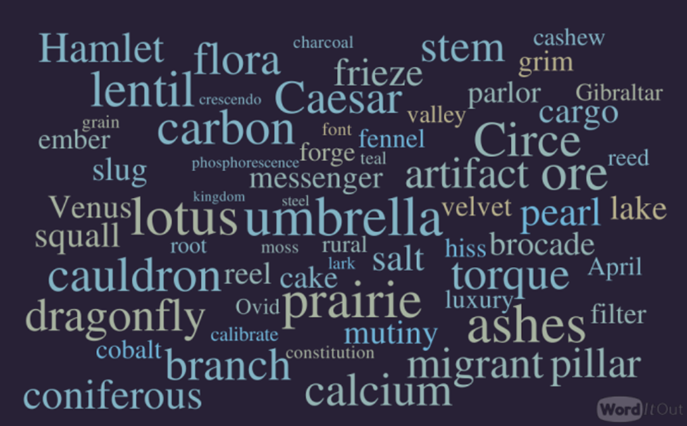

#1 Create a word bank of 20-30 words
#2 Goal: Try to use all the words in the word bank for the creation of a poem.
3. Let the words expand your creativity into uncharted territory
4. Share

Word bank:
Reflection sounds version angry answers voice exhausted
Wound meal night vision rocks celebration bullet time
Distant friend images rules boundaries healed
Photos free honor funny birthday treat pretend clock us

Poem created within 15 minutes. Two passes through for clarity and corrections. One read through with minor corrections.

Reflection on the Departure
We had our final meal last night.
It was not my birthday,
there was no celebration,
no funny photo to mark the occasion,
no joyful voice to announce a surprise,
but rather a presentation of an unwanted treat,
that told me that the clock had stopped
for us.
That, finally, we would both be free.
I was not angry, for the rocks had
hit the windshield long ago,
shattering my vision
of what it meant to honor vows
rules that we pretend to follow
but we no longer shared,
boundaries overrun by weeds
exhausted sounds that no longer had meanings
in conversations, arguments that produced
no answers until that dinner was finished
the bullets were fired,
the wounds made
that will be bandaged,
healed over time,
when the memories are distant images
of a former friend
you once had dinner with.
Copyright JL Smith 2020

